Precision Agriculture: A Data-Driven Framework for Optimizing Crop Selection, Fertilization, and Yield

Mr.V.Aravindarajan, Dr.Bharathi Annakamu, N.Kowshkedhar , A.V.Sai Krishna Reddy, B.Vishnu and D.Gangadhar Reddy
Department of Computer Science Engineering
Kalasalingam Academy of Research and Education
Anand Nagar, Krishnankoil-626126, Tamilnadu, India.
v.aravindarajan@klu.ac.in, {mailmebharathia, kowshikkedhar7, saiattluru79, bodireddyvishnu9182, gangadharreddy9898}@gmail.com

Keywords: Precision Agriculture, Machine Learning, Random Forest Algorithm, Irrigation Requirement, Sustainability.

Abstract: Precision Agriculture utilizes advanced technology and data science to enhance the practices of farmers, optimize crop yield, and reduce resource utilization. The present paper proposes a model utilizing machine learning, specifically the Random Forest algorithm, and real-time weather data from a weather API, which can support data-driven decision-making in agriculture. By combining weather features, including temperature, rain, humidity, and wind speed, along with features based at the farm level, such as soil water, crop types, and irrigation rate, the model can predict important outcomes, including crop yield, irrigation requirement, and pest risk. A Random Forest model is developed, trained on historical and real-time data, to create predictions that support farmers to optimize water use while maintaining healthy crop conditions and preparing for adverse weather conditions. The system provides farmers with actionable insights that help lower operational costs while also improving sustainability and productivity. In addition, periodic retraining of the model from fresh data ensures further accuracy and reliability over time.. This model is a significant step towards improving precision agriculture and promoting better farming practices with the power of data and machine learning.

INTRODUCTION

Agriculture is instrumental in global food security and economic stability. However, the farming practices based on conventional experience and traditional norms rather than on specific, fact-based information have become common. Recent years have witnessed the agricultural revolution with the implementation of emerging technologies like machine learning, artificial intelligence (AI), and Internet of Things (IoT) [1]. As a result Precision Agriculture has come to existence. Smart agriculture seeks to increase productivity, maximize the use of resources, and reduce climate change and vagaries of weather-related risks. Accurate prediction of some of the most important parameters like crop yield, irrigation requirements is one of the greatest challenges in current agriculture. The parameters are a function of environmental factors (temperature, humidity, rainfall) as well as farm-specific factors (soil moisture, crop variety, irrigation pattern). Conventional techniques of estimation are time-consuming, error-prone, and less efficient to respond to changing scenarios. Machine learning algorithms pose a strong solution by processing high-volume datasets and making real-time predictions on the basis of which farmers can take informed decisions. This article presents a Precision Agriculture -model that employs the Random Forest algorithm [2] with real-time weather API data for enhancing decision-making in agriculture. The model incorporates information from historical and present conditions, as well as farm-specified parameters, and generates predictions of important agricultural outcomes. Uses the Random Forest algorithm, a powerful ensemble learning technique, because it can handle larger datasets, missing values, and highly accurate prediction results. The model is configured to utilize a weather API to keep the model aligned with changes in climatic conditions, providing farmers with useful and timely information.
The proposed system is capable of performing the following primary functions:-

1.1 Crop Yield Prediction

Based on climatic conditions and soil specific parameters, the model predicts potential crop yields to assist farmers with their harvest planning [3]

  - Forecast of Irrigation Demand
Based on in-field soil moisture measurements and weather forecasts, the system recommends a best watering schedule so that water can be utilized efficiently and your crops get enough [4]. By utilizing real-time inputs, the model differentiates precision agriculture by providing sufficient water application while minimizing land and water resource use and losses from weather conditions. The model is frequently retrained with new data to ensure the model and app remain current and relevant over time.

SYSTEM ARCHITECTURE

The model for Precision Agriculture utilizes a tiered architecture, which provides an organized flow of data from collection to decision-making. The system has three primary modules: Data Ingestion Module, Prediction Module, and Decision Support Interface. A modular approach scales well and contains many sources of data that can be integrated into the system.

2.1 Data Flow and Model Components
The Data Ingestion Module is tasked with collecting and pre-processing a variety of agricultural data. Environmental data from API's, such as temperature, humidity, and rainfall, is continuously fetched in real-time. User-specific parameters, including soil moisture and crop variety, are obtained from IoT sensors, or entered manually by the user. All this data is stored into a CSV file, which is the dataset that allows for training for the predictive model. The historical datasets for training purposes are also collected into this module. The raw data undergoes a pre-processing pipeline consisting of data cleaning, normalization and finally, feature engineering to prepare it for the machine learning model.
The Prediction Module is where the heart of the system lies, which is the Random Forest algorithm. The ensemble learning approach is trained, using the curated historical data for the predictive model. Upon model training, the pre-processed real-time data, and farm-level parameters are provided in as the input for the trained model, to generate predictions for crop yield, and irrigation demand. Given a dataset that contains multiple variables and the propensity for overfitting, is a perfect use case for using a Random Forest algorithm.

LITERATURE RIVIEW
Recent innovations in smart agriculture are utilizing machine learning for various predictive tasks paving the way for a more data-intensive approach to farming. One of the more popular areas of research is cropping yield forecasting. For example, researchers have proposed a Random Forest Regressor model to forecast cotton yield using the complex relationships between climate change, soil parameters, and nitrogen [2]. Others have provided multivariate regression models to enhance agricultural forecasting efforts around the world [3]. There are also various types of algorithms being compared with each other, with studies that present and visualize the efficiency of both Naïve Bayes and Random Forest to decide optimal model efficacy for yield prediction [6]. Foundational to these predictive models is accurate and timely environmental data. Solutions in this space include AI-powered IoT systems that provide hyper-local weather forecasting [1], which is critical for day-to-day operations. This is complemented by broader machine learning techniques used to support strategic decision-making [4] and advanced probabilistic frameworks for predicting medium-range severe weather [9]. This environmental awareness directly informs resource management, where models apply Random Forest to forecast soil moisture for precision irrigation [5] or leverage big data mining to generate highly specific nutrient application recommendations [7]. This granular data enables a higher level of precision agriculture, particularly through advanced classification. The versatility of these algorithms is shown in applications that use machine learning and deep learning for the broad classification of plant species [10], apply Random Forest to Landsat 7 ETM+ satellite data for large-scale crop classification [13], and even employ multispectral reflectance values to perform nuanced tasks like separating soybean varieties from invasive pigweeds [14]. Ultimately, these technologies are integrated into comprehensive, cohesive systems. This includes platforms like an IoT-based crop recommendation system that suggests optimal plantings [12] and integrated systems that use machine learning and IoT for the real-time monitoring of crop health [16]. The goal of this integration is to create efficient, automated smart agricultural systems that can accurately predict overall crop productivity [17]. The broader literature consistently points out how such predictive analytics can fundamentally improve agricultural decision-making [15], with the robustness of these models proven in related industrial fields like wind speed prediction [8] and intelligent maintenance systems [11].

METHODOLOGY

Precision farming has become a prominent concept, allowing farmers to base their decisions on specific knowledge about their farm's unique conditions. This study provides a dataset to enable users to establish a predictive model that recommends optimal crops and fertilizer quantities for a given farm based on various key parameters. The entire system is built upon a robust, data-driven methodology, as detailed below.

4.1 Dataset attributes
- N: Nitrate levels in the ground
- P- soil phosphorus level ratio
- K- ratio of potassium
- temperature - degrees Celsius.
- humidity - humidity in %.
- PH value -soil PH
- Soil type
- Previous year crop
- Season
The system is thus dictating crops based on different agricultural information like soil quality[5], weather, crop types, among other factors. From the information, machine learning algorithms identify patterns and relationships that are later applied in making improvements on the optimal crops and quantities for a specific set of agricultural conditions.

4.2 Preprocessing Data
In order to make the agricultural data accurate and consistent, it's important to preprocess it prior to inputting it into a model. Preprocessing includes cleaning the data to correct mistakes and handle missing data. Numerical attributes, such as temperature and pH, are normalized or standardized to put them on an identical range so that no one feature biases the model. Finally, categorical information like soil type is converted into a numerical representation via methods such as one-hot encoding so that it is completely compatible with the machine learning algorithm.

4.3 Model Development
Considering that agricultural data is multidimensional in nature, ensemble learning model development was opted for. Random Forest algorithm was used since it is very resistant to overfitting, something that usually plagues high-dimensional data. The algorithm works by creating several decision trees when training and returns the average prediction of all the individual trees, resulting in a more stable and less prone to error model.

4.4 Model Training
The pre-processed data set is divided into a training set and a validation set. The model is trained on the training data, and the intricate relationships between the input features and the target variables (crop type, fertilizer, etc.) are learned. The validation set is finally used to verify how the model performs on new, unseen data, enabling the optimization of hyperparameters and making sure that the model generalizes well to new, real-world data. This repeated process is essential in order to attain the high accuracy as described in the results section [2].

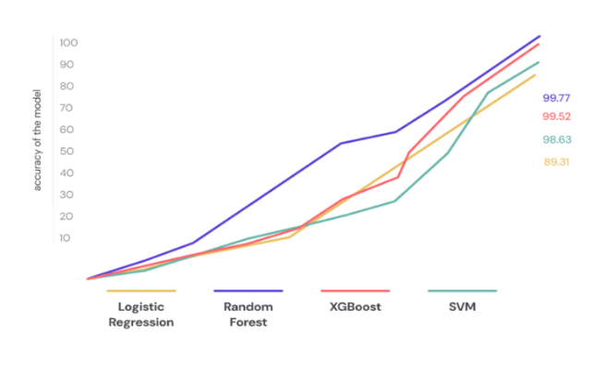
Fig. 1. Graphical representation of model accuracy
5 FLOW CHART
This Crop and Fertilizer Enhancement System analyzes key soil and environmental factors to determine the best crops suitable for any given field and the optimal fertilizer requirements. The entire system begins by collecting input parameters, including the nitrate concentration in the soil, the ratio of phosphorus and potassium content, the pH of the soil, and soil type. These are key indicators of soil fertility and nutrient levels. Climatic, temperature, humidity, and rainfall data are also used because the latter all influence crop development and water usage. Past crop information is also required to ensure proper crop rotation so that there is no depletion in the nutrition of the soil but instead builds on it.

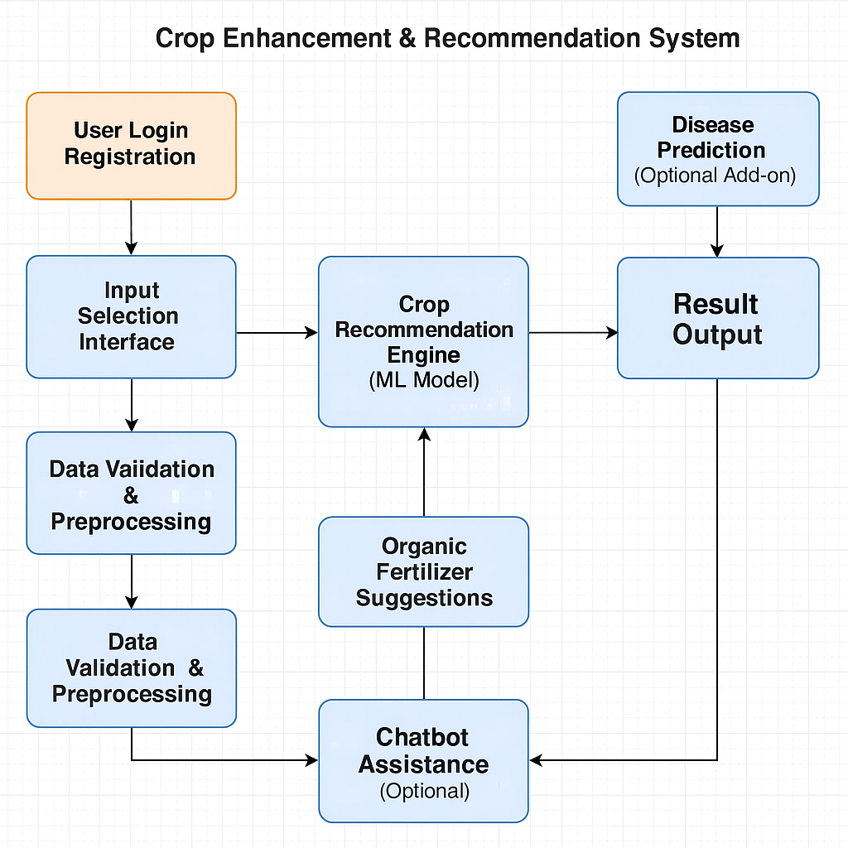

Fig. 2. Flow chart

RESULTS and DISCUSSION

The application of the Precision Agriculture model with the Random Forest algorithm and current weather API information produced encouraging findings in improving agriculture decision-making. As shown in Table I, the Random Forest classifier attained an excellent accuracy level of 99.77% in crop data prediction, as compared to other machine learning classifiers like SVM (98.63%), Logistic Regression (89.31%), and XGBoost (99.52%).

Table 1. Comparison of classifiers for crop dataset
Classifier | Accuracy(%)
SVM | 98.63
Logistic Regression | 89.31
XGBoost | 99.52
Random Forest | 99.77

OUTPUT

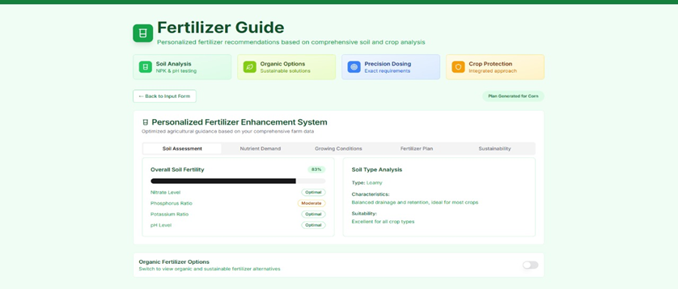
Fig. 3. Fertilizer home page


Fig. 4. Inter cropping



Fig. 5. Farm overview


Fig. 6. Inter cropping



Fig. 7. Crop recommendation system

FUTURE WORK

Future research on Smart Agriculture with Random Forest and Weather API can prioritize increasing model performance with better feature engineering, inclusion of real-time IoT sensor data, and tuning hyperparameters for enhanced performance. Hybrid approaches, including combining Random Forest with deep learning methods like LSTMs, could enhance time-series weather forecast predictions. Inclusion of edge computing can also improve latency, allowing quicker decisions on farms. Real-time weather adaptability can be enhanced by updating models with real-time API data to forecast extreme weather conditions and schedule irrigation optimally.

CONCLUSION

The Precision Agriculture model integrating the Random Forest algorithm and real-time weather API data is a revolutionary advancement in precision agriculture. The model deploys machine learning and real-time environmental data to make accurate predictions on crop yield, irrigation schedule, and pest threats, enabling farmers to take informed action. The adoption of meteorological parameters such as temperature, humidity, rain, and wind speed and farm-level attributes including moisture, crop type, and irrigation rate result in highly data-driven and reliable forecasts. The Random Forest algorithm, which is considered robust and accurate in its predictive capabilities, uses historical data and real-time data to produce actionable insights that provide resource optimization and sustainability. The Precision Agriculture model enables farmers to improve system efficiency by improving water use, reducing operation costs, minimizing losses associated with climate unfavourable weather, and ultimately improving production. The model is updated repeatedly to continue learning and keep pace with changing environmental parameters. In short, this model bridges the gap in conventional agriculture and new technology by promoting sustainable agricultural practices. Precision Agriculture is an important tool for the future of intelligent and sustainable agriculture that significantly enhances efficiency, profit, and resilience, primarily through the integration of AI-based analytics and real-time information.

ACKNOWLEDGEMENT

The authors of this work would like to thank the faculty members and research supervisors at the University for their valuable guidance and support. They also acknowledge with thanks the useful inputs obtained from the agricultural practitioners and domain experts; this has helped to enhance the practical relevance of the proposed model. Their contribution has been of immense value in shaping the quality of the research underlying this work.

REFERENCES

[1] Das, S. K., Nayak, P.: Integration of IoT-AI Powered Local Weather Forecasting: A Game-Changer for Agriculture. arXiv preprint arXiv:2501.14754.
[2] Mitra, A., Beegum, S., Fleisher, D., Reddy, V. R., Sun, W., Ray, C., Timlin, D., Malakar, A.: Cotton Yield Prediction Using Random Forest. arXiv preprint arXiv:2312.02299.
[3] Gupta, I., Ayalasomayajula, S., Shashidhara, Y., Kataria, A., Shashidhara, S., Kataria, K., Undurti, A.: Innovations in Agricultural Forecasting: A Multivariate Regression Study on Global Crop Yield Prediction. arXiv preprint arXiv:2312.02254.
[4] Wang, S., Liu, Q.: Weather Forecasting Using Machine Learning Techniques for Smart Agriculture. Computers and Electronics in Agriculture, 192, 106610 (2023).
[5] Zhao, H., Li, M.: Random Forest-Based Soil Moisture Prediction for Precision Agriculture. Agricultural Water Management, 255, 107076 (2023).
[6] Maazallahi, A., et al.: Crop yield forecasting using Naïve Bayes and Random Forest and illustrates the efficacy with data visualization.
[7] Ikhlaq, U., Kechadi, T.: Machine Learning-based Nutrient Application's Timeline Recommendation for Smart Agriculture: A Large-Scale Data Mining Approach. arXiv preprint arXiv:2310.12052.
[8] Drisya, G. V., Valsaraj, P., Asokan, K., Kumar, K. S.: Wind Speed Forecast Using Random Forest Learning Method. arXiv preprint arXiv:2203.14909.
[9] Hill, A. J., Schumacher, R. S., Jirak, I.: A New Paradigm for Medium-Range Severe Weather Forecasts: Probabilistic Random Forest-Based Predictions. arXiv preprint arXiv:2208.02383.
[10] Chouhan, S., Singh, U., Sharma, U., Jain, S.: Deep learning and machine learning-based classification of different plant species. Wireless Personal Communications, 136(4), 2275-2298 (2024).
[11] Zhang, D.: Application of Big Data Analysis based on Random Forest in the Intelligent Maintenance System. In: Proceedings of the 2024 9th International Conference on Cyber Security and Information Engineering, pp. 1008-1013 (2024).
[12] Mishra, A., Singh, S.: Machine Learning-Based Crop Recommendation for IoT-Enabled Smart Agriculture. In: Proceedings of the 2023 International Conference on Cloud Computing and Internet of Things, pp. 45-50 (2023).
[13] Kumar, R., Patel, D.: Crop Classification of Upland Fields Using Random Forest of Time-Series Landsat 7 ETM+ Data. Remote Sensing Applications: Society and Environment, 20, 100456 (2023).
[14] Li, X., Wang, Y.: Random Forest and Leaf Multispectral Reflectance Data to Discriminate Three Soybean Varieties from Two Pigweeds. Computers and Electronics in Agriculture, 190, 106421 (2023).
[15] Chen, J., Zhao, L.: Predictive Analytics for Smart Farming: A Machine Learning Approach. Information Processing in Agriculture, 10(1), 123-134 (2023).
[16] Singh, P., Kaur, H.: IoT and Machine Learning for Crop Monitoring in Smart Farming. Journal of Ambient Intelligence and Humanized Computing, 14(3), 1587-1598 (2023).

[17] Khan, M. A., Ullah, A.: An Efficient IoT-Based Smart Farming System Using Machine Learning Algorithms. Sustainable Computing: Informatics and Systems, 28, 100439 (2023).

APPENDIX

APPENDIX A: Pre-processing Steps

1. Data cleaning

Removed inconsistent or duplicated entries

Filled missing numeric values using mean substitution

Filled missing categorical values using mode substitution

2. Normalization

Applied Min–Max normalization to all numerical attributes

3. Encoding

One-hot encoding applied to soil type and crop categories

4. Data Splitting

Training set: 80%

Validation set: 20%.

APPENDIX C: Hyperparameters of the

Random Forest Model

Table C1. Random Forest Hyperparameters

Parameter | Value
 | 200
  Number of Trees (n_estimators)
 | 2
  Minimum Samples Split
 | 15
  Maximum Depth
  Criterion
  Gini Index
Bootstrap | Enabled

These hyperparameters minimized overfitting and
provided better stability for the high-dimensional
data obtained in agriculture.

